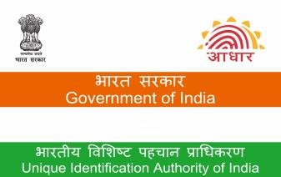  नामकन 页म/ Enrolment No.: 2906/07419/01431  To  े  महश मार  Mahesh Kumar  S/O: Mahendra Singh, Ward No 04,  VTC: Jhanjharpur, PO: Jhanjharpur,  Sub District: Jhanjharpur, District: Madhubani,  State: Bihar,  PIN Code: 847404,  Mobile: 9155235790    Signature Not Verified  Digitally signed by DS Unique  Identification Authority of India  05  Date: 2025.03.31 12:48:59 IST  3和3eT和/your A adha arNO.:  3352 4789 5691 VID : 9158 7069 9279 6926 |  |  |  | 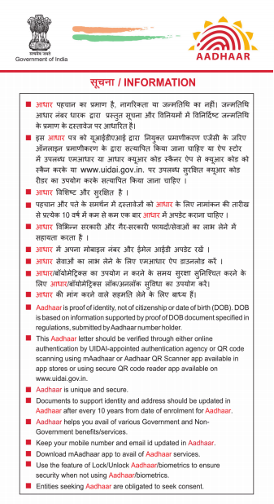
Aadhaar no. issued: 09/12/2014 |  | े  महश मार  Mahesh Kumar  ज=म fतfथ/DOB: 15/01/2001 页ष/ MALE  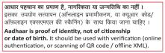 |  | Detai ls as on: 31/03/2025 | 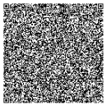  आξम:ज: मह、ζ fसह, वॉडr न 04, झंझारर, झंझारर, मबनी,  fबहार - 847404  Address:  S/O: Mahendra Singh, Ward No 04, Jhanjharpur, PO: Jhanjharpur, DIST: Madhubani,  Bihar - 847404  3352 4789 5691
3352 4789 5691
 |  |  |  | VID : 9158 7069 9279 6926

